1. **Login to lennoxPros “[liidaveqa.com](http://liidaveqa.com" \t "_blank)” using** 
   1. **Username [lenproautomation8@lenqat.com](mailto:lenproautomation8@lenqat.com" \t "_blank)**
   2. **Password Community17**

**2.       Go to Sales Tools + Build A Proposal from the Menu (Menu Navigation should come from test data sheet)**

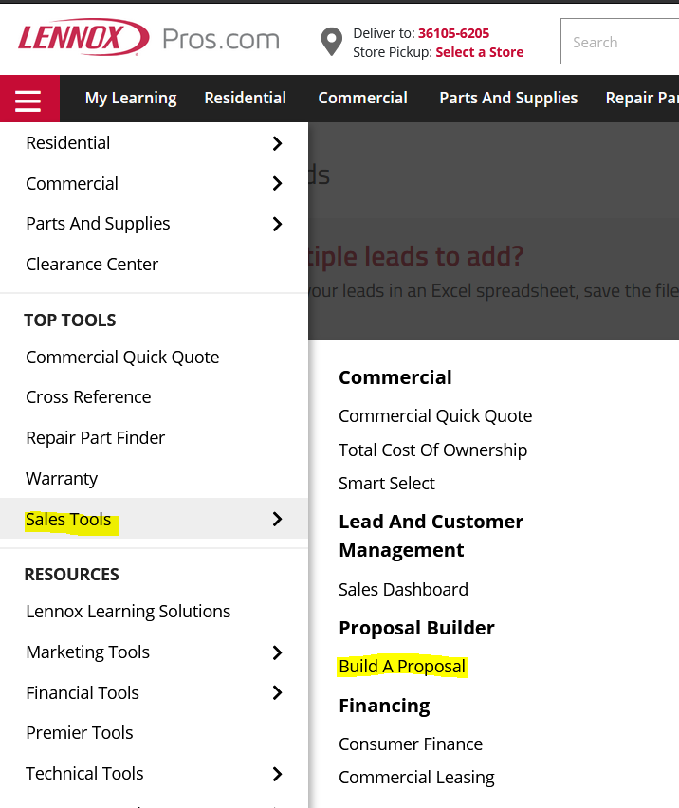

**3. Select Lead**

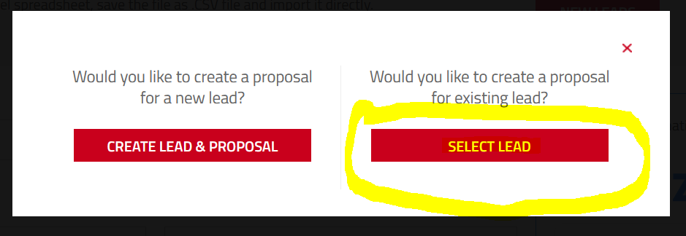

**4. Add Lead**

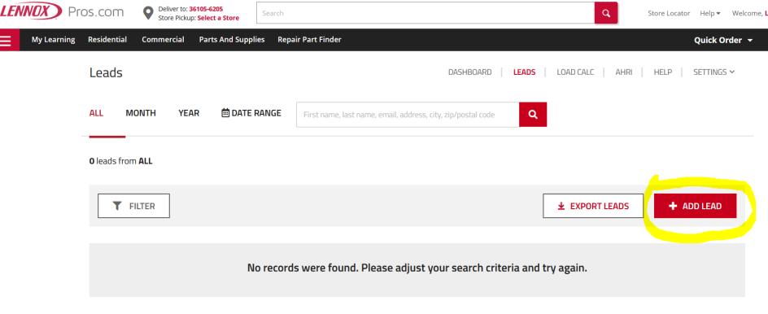

**5. Enter the following details (All the input should come from Excel)**

* **Enter First Name**
* **Last Name**
* **Email**
* **Phone Number**
* **Scheduling Request Date (Input for Date and Time should come from Excel)**
* **Add Document (Other from drop down)**
* **Add Image**

**(Add Document & Image should be data driven from the test data excel, i.e. it should upload only when the data is provided else do not upload)**

**6. Save Lead**

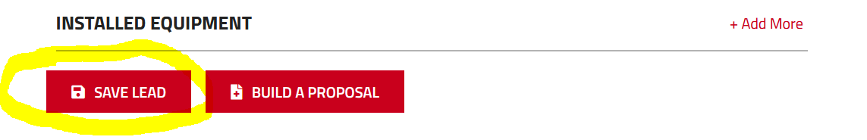

**7. Validate that the lead got saved successfully**



**Other requirements**

* **This should be a Maven project. Use Page Object Model to derive this model and all inputs must be given from Excel**
* **Browser is data driven**
* **Provide a Extent reports with detailed steps & screen shots**
* **Please have three data sets in the test data**
* **Please upload the project to either Git\GitHub and provide us the link to the code base.**

**Nice to have**

* **Use a free tier VSTS\AzureDevops pipeline accounts to setup the pipeline for test execution**

**Reach out to me for any clarifications.**